**PROCESS FLOW : request** PO creation => SO validation => Project to create from the SO

1. Explanation IC process flow
2. Request received from the business:

* SUP
* CR
* IMP
* UPG
* MSN

1. Summary flow
2. Process flow including accounting bookings



1. **PO CREATION**

* Go to the Purchase Requests and Orders work center (menu SAP).
* Go to Purchase Orders view.
* Under the common task select “New Purchase Order”.
* Click on “View all”

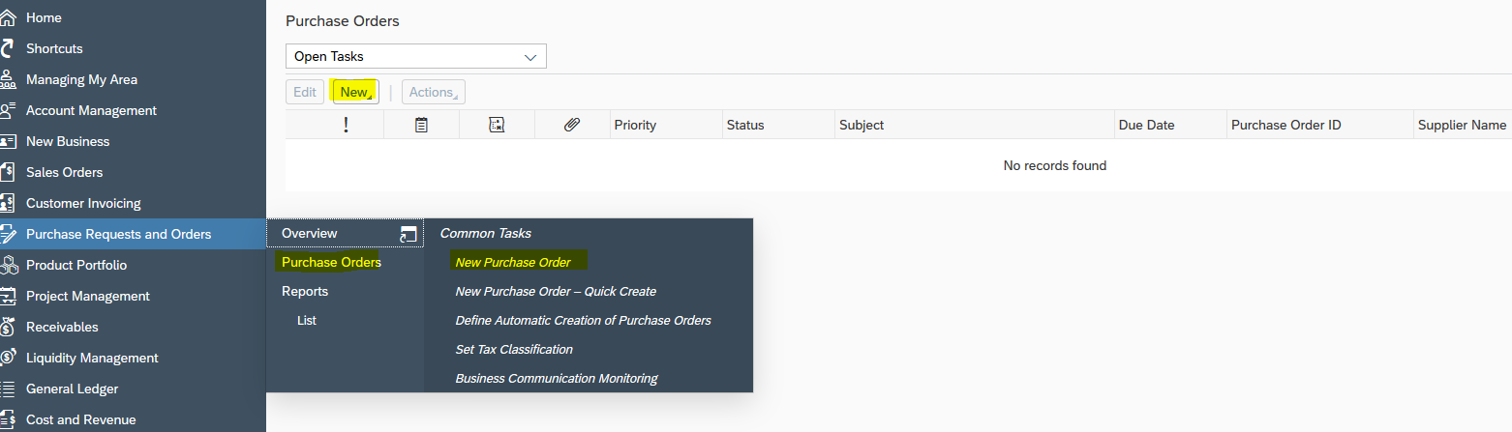

Following filed must be completed :

* Supplier
* Company
* Bill to

For e.g : Singapore team will work on project managed by Mediagenix BE

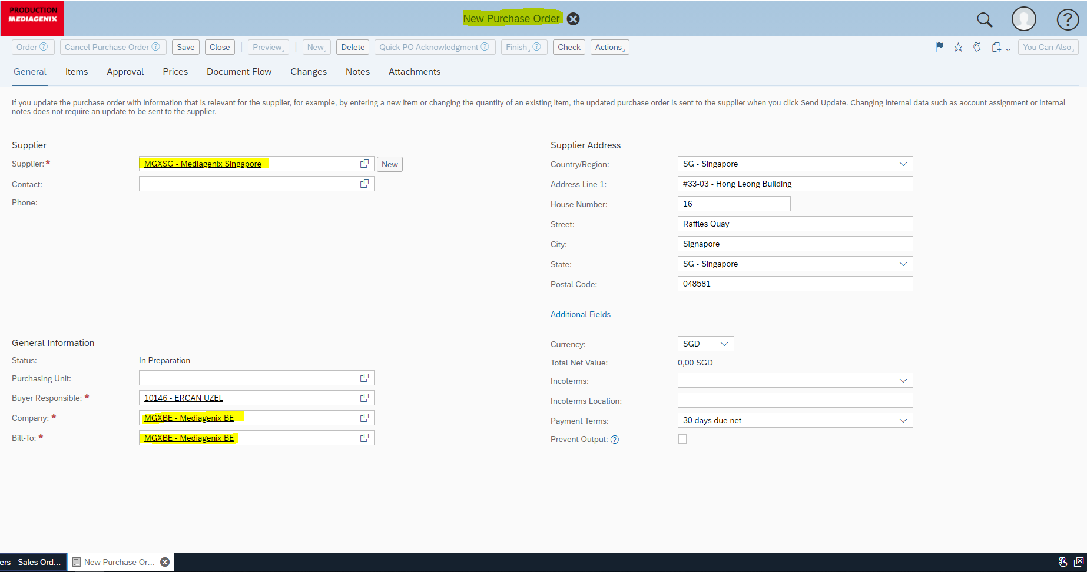

Go to the items tab and click on Add Row to add the following product IDs

All the products starting with P094xxxx should be added to the PO in order to allow the concerned team booking their time on the correct product => **P0940001 to P0940019 + CO9010001**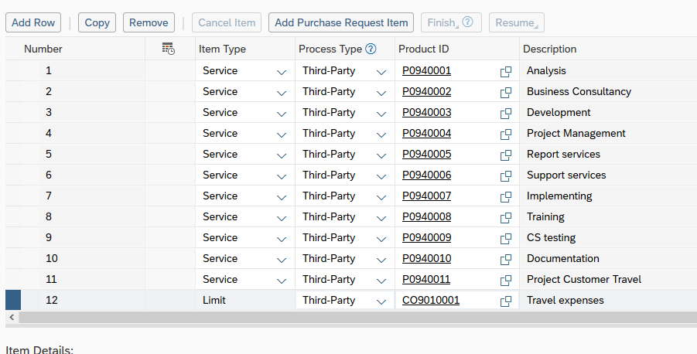

**Delivery date: beginning of the month of request or first day of the year to be sure that it includes all timesheets**

**In “*Basic Data*” :**

* Add the quantity (always 1)
* Tick the boxes : “Goods and Services receipt Expected”, “Invoice Expected” , “Time recording Required” and “Unlimited Over Delivery”

**EXPENSES**

**Item Type: Limit**

**Change item type first and then add the Product ID**

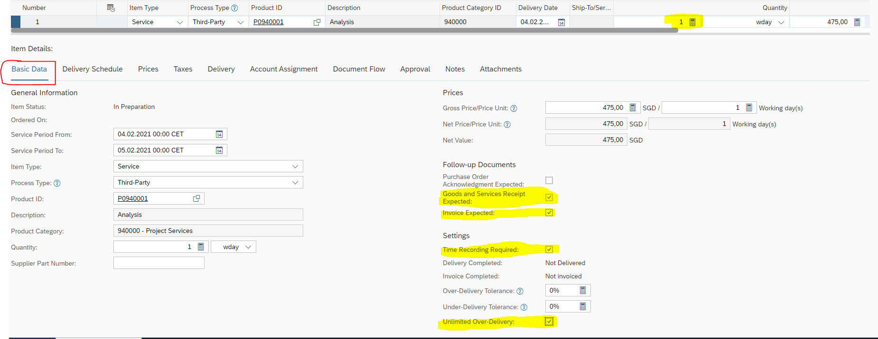

**“*Delivery*” tab**

Add “Customer” of project

Check if “Site” has been filled in (should be the same as company)

Put “Service period to” to 31.12.9999

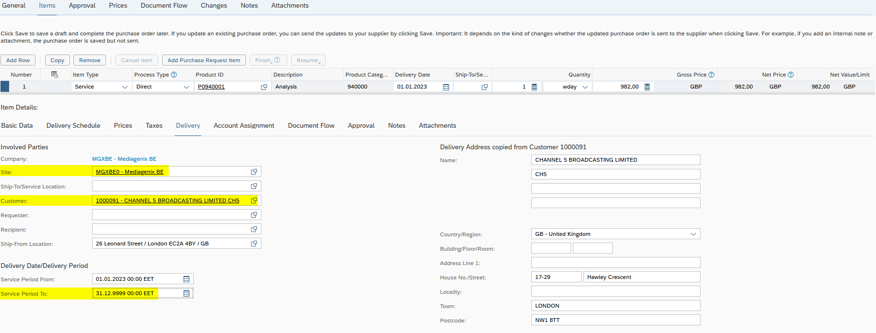

**In “*Account assignment” :***

Select the “*PRO – Project task”* as **account assignment** type

Add the project ID

Percentage Field should be 100%

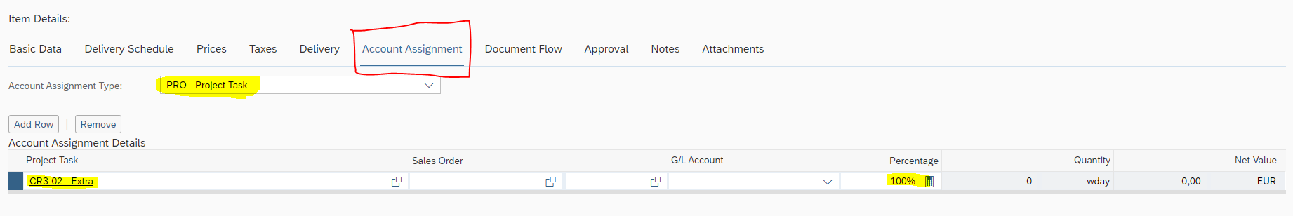

Once all the above requirements are completed, click on “*Check*” :



If no error click on “*Order*” otherwise consult the issues :



**TIPS :** during the creation of lines in items tab (P0940001 to P0940019), make the above step once for the first line and then copy past the first line by modifying the last number of the Product ID :

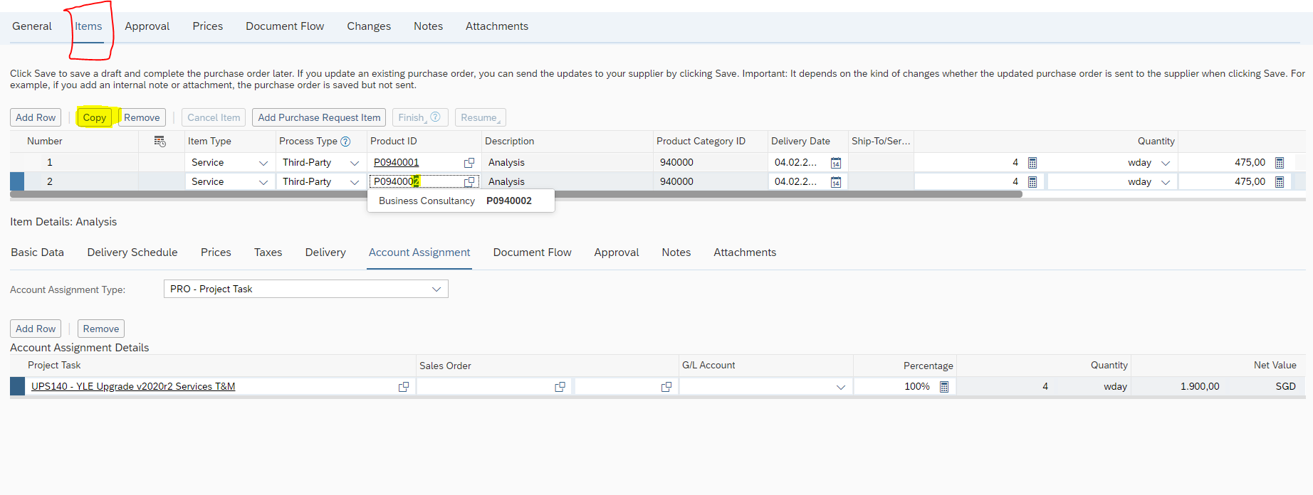

* **Save. The PO is now created**
* **The PO will create automatically a SO**

**To check if the PO was created correctly, use this Report in SAP**

* In Selection: delete Purchase Order Creation Date

**SO validation**

Go to the Sales Orders work center

Go to Sales orders

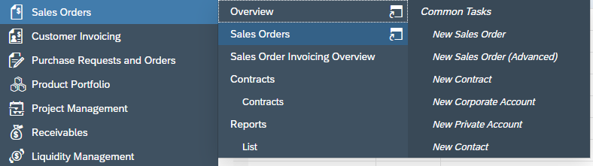

Select the newly created Sales Order with the status “*In preparation”*

Click on “View all”

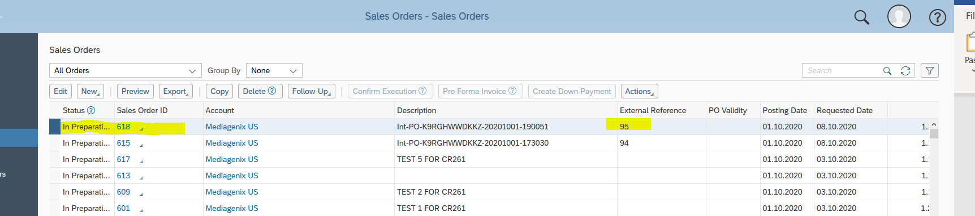

The origin of your sales order must be A2A message meaning : automatic sales order for intercompany project

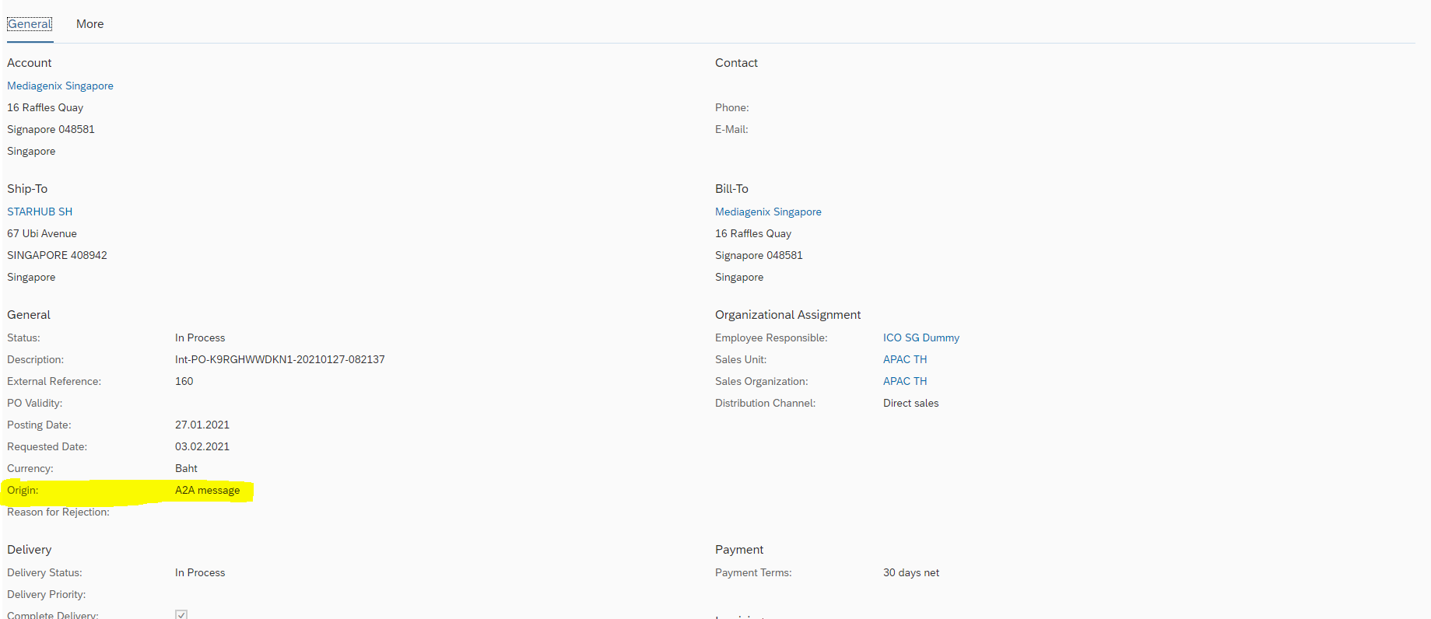

In “*General”* tab update the sales unit accordingly, *for e.g* Purchase order received by Mediagenix Thailand (Supplier) and bill to party is Mediagenix Singapore :

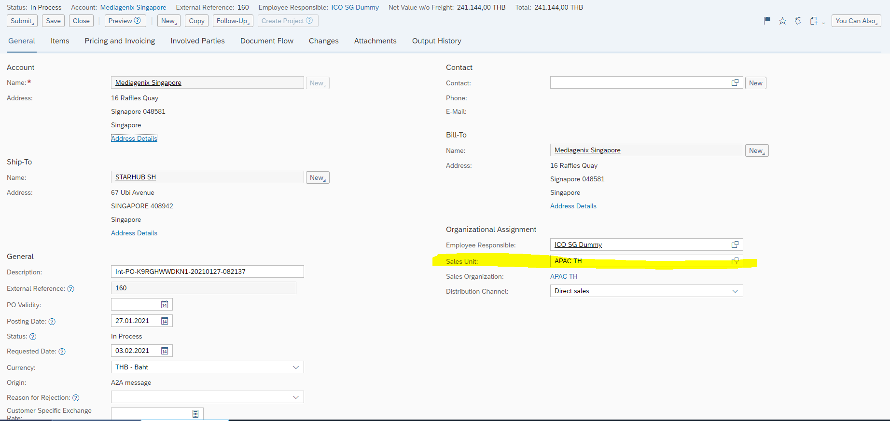

So in this case the sales unit must be : **APAC TH** **-> New way of working: INTERCO TH**

Let’s take an additional example, Purchase order received by Mediagenix NV (Supplier) and bill to party is Mediagenix US in this case the sales units is **AMERICAS EMEA -> New way of working: INTERCO BE**

**For Bebanjo: INTERCO UK**

In “*Items”* check all the lines are well booked as *Service – time and material (project) :*

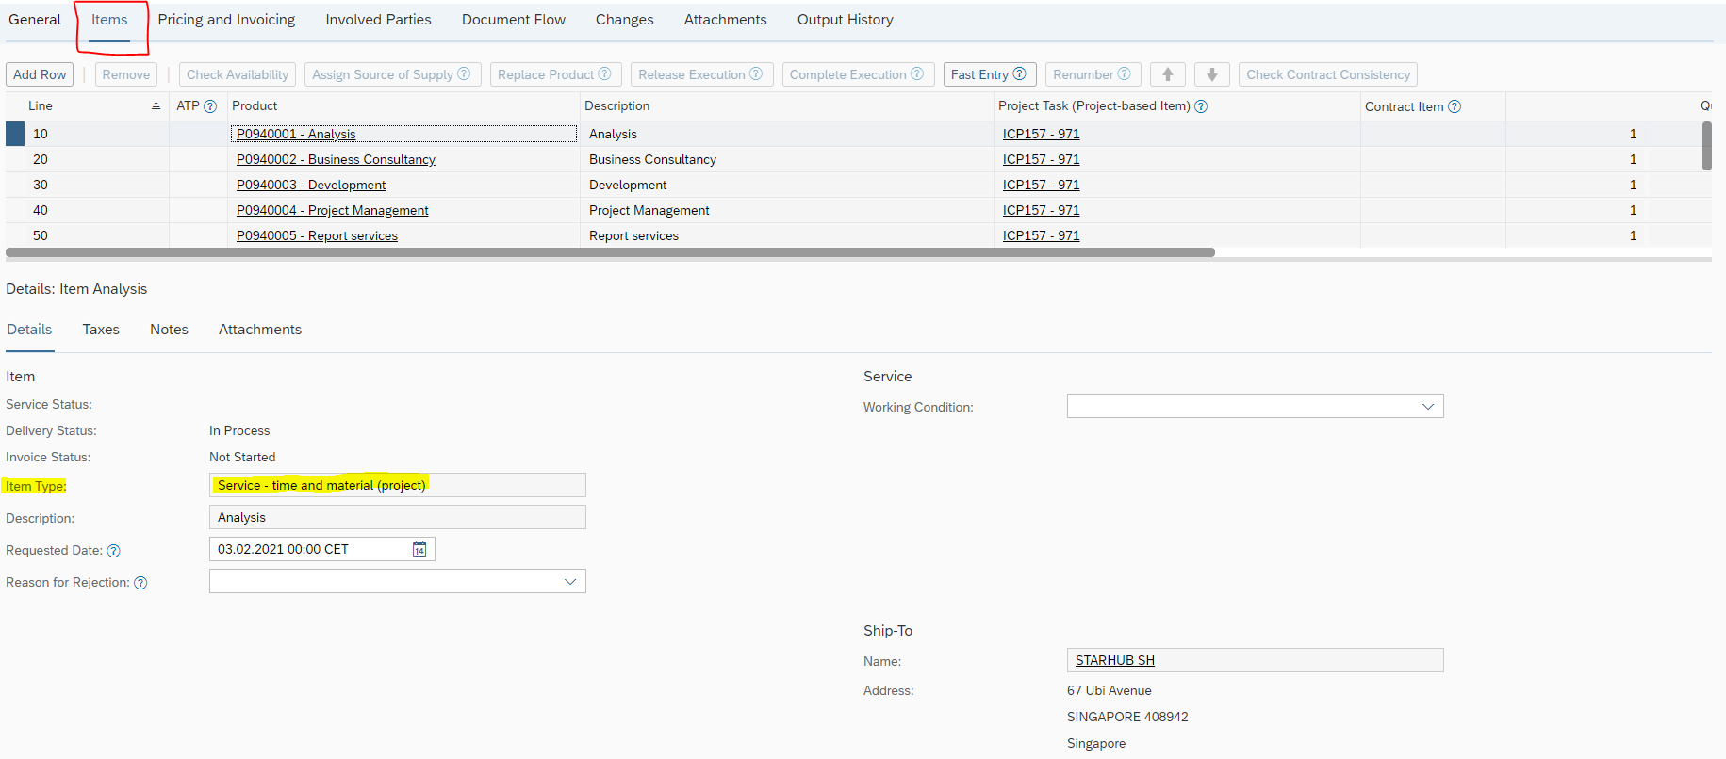

**Project to create from the SO**

In “*Involved parties”* check that parties are well mentioned :

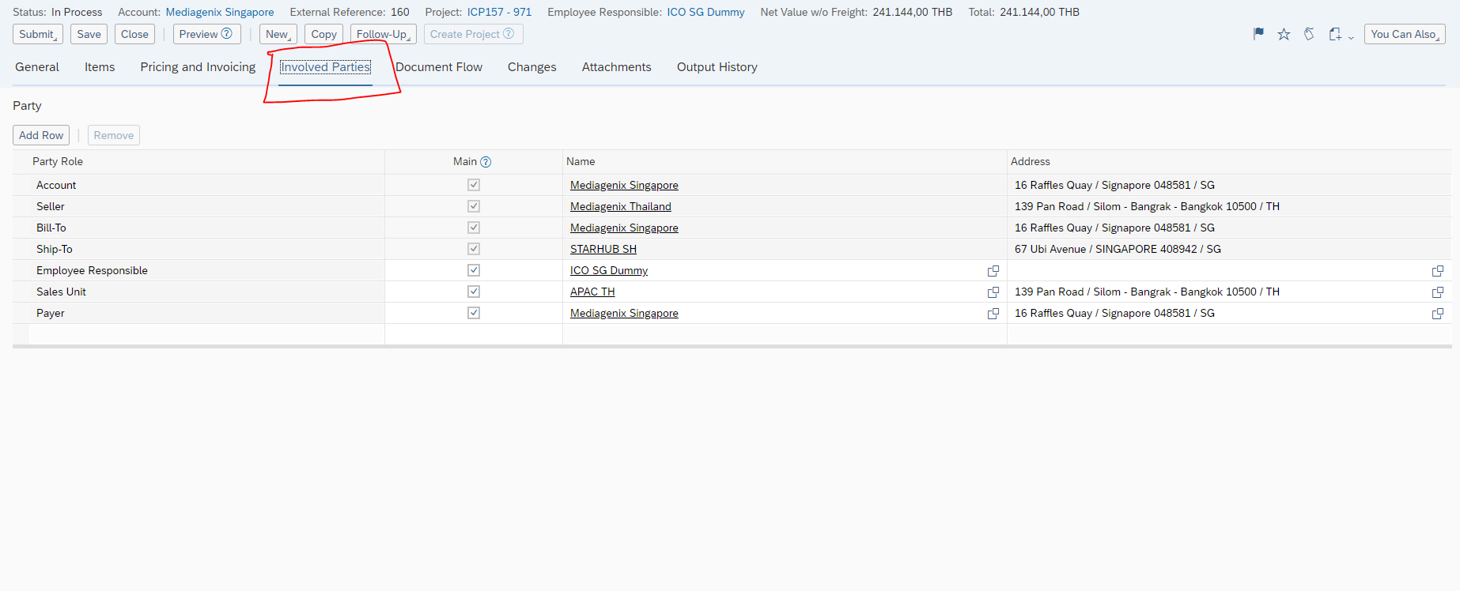

Click on “*Create Project”*



and complete the following window with the appropriate information in accordance with the flow :

* Project Structure : always “*Only Project Header”*
* Person Responsible : select the “Seller” unit, *for e.g* Mediagenix NV = 8999997
  + - * **Bebanjo: Interco UK**
* Responsible Unit : always *“Operations Organisation”* of the seller (ex. EMEA BE)
  + - * **Operations Organisation – UK**
* Intercompany Project : always ticked
* Duration : 1 Day(s)

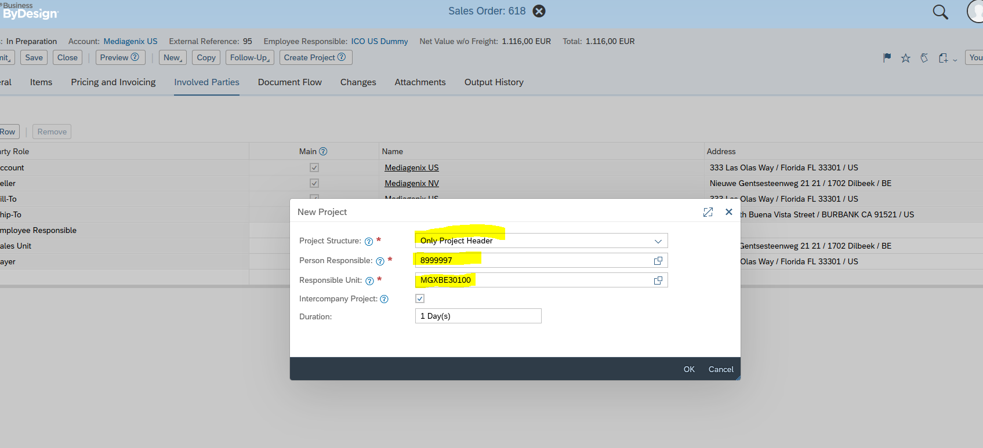

Once information completed => Click on “OK”

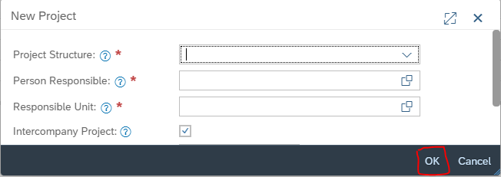

Let’s take another example : Mediagenix Thailand team will work on project handle by Mediagenix BE

PO Side :

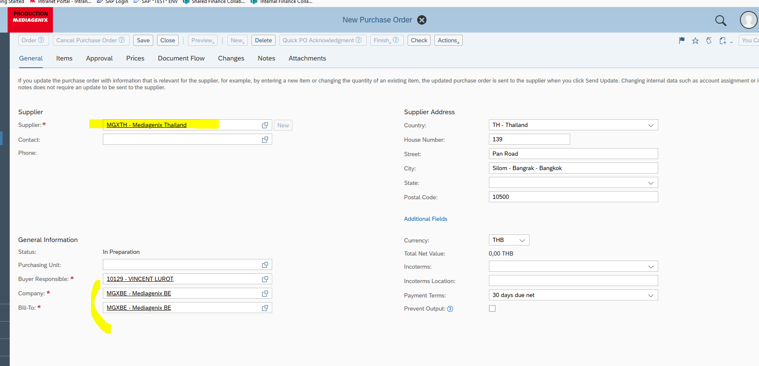

SO Side :

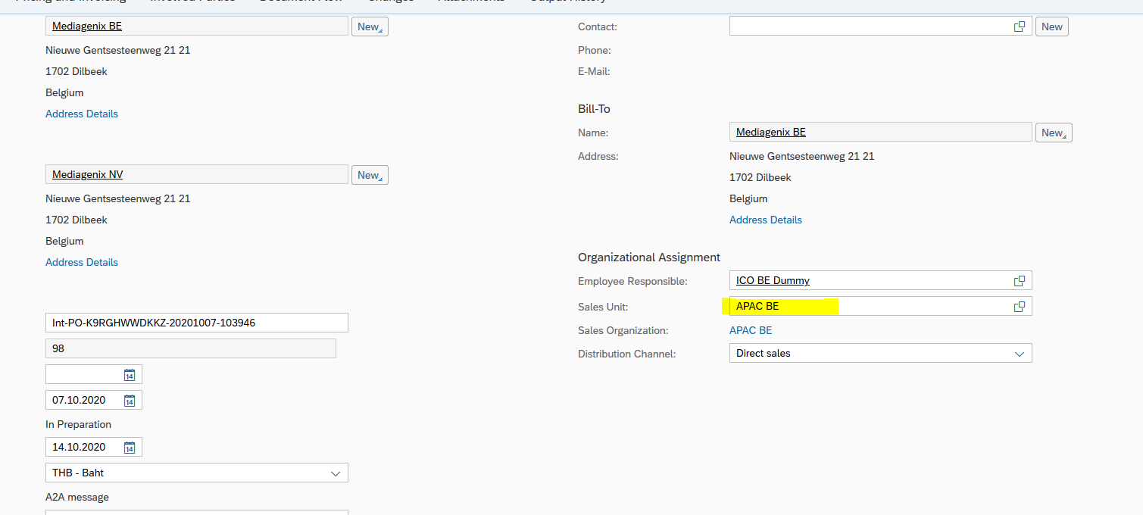

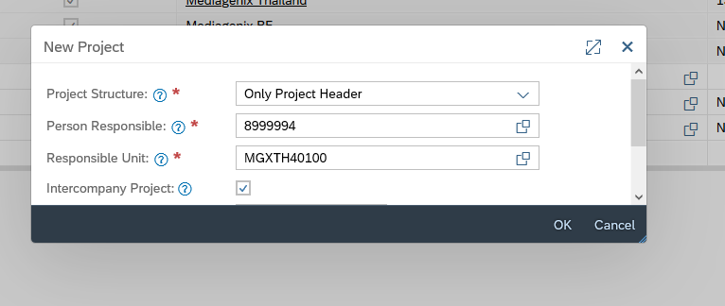

1. Invoicing process

* To be filled by Karelian?
* Don’t forget the GR/IR clearing step (the one no one does currently)